Warm-Up: Cornelius Vanderbilt

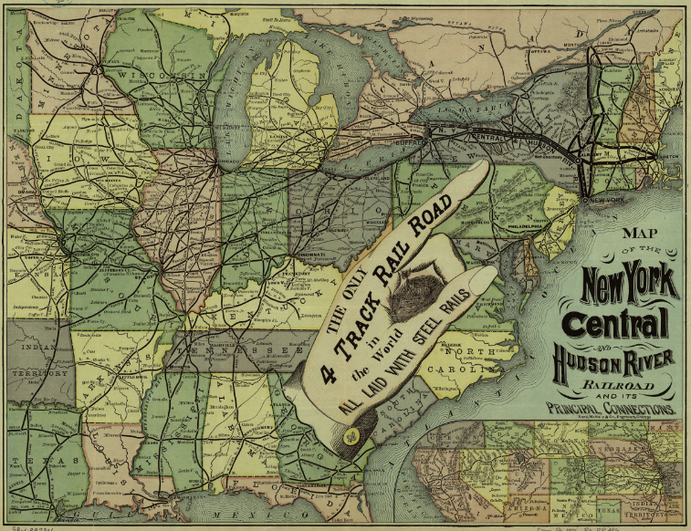
Shipping and railroad tycoon Cornelius Vanderbilt (1794-1877) was a self-made multi-millionaire who became one of the wealthiest Americans of the 19th century. As a boy, he worked with his father, who operated a boat that ferried cargo between Staten Island, New York, where they lived, and Manhattan. After working as a steamship captain, Vanderbilt went into business for himself in the late 1820s, and eventually became one of the country’s largest steamship operators. In the process, the Commodore, as he was publicly nicknamed, gained a reputation for being fiercely competitive and ruthless. In the 1860s, he shifted his focus to the railroad industry, where he built another empire and helped make railroad transportation more efficient. When Vanderbilt died, he was worth more than $100 million. In the 1860s, Vanderbilt shifted his focus from shipping to the railroad industry, which was entering a period of great expansion. He gained control of a number of railway lines operating between Chicago and New York and established an interregional railroad system.
- - - - - - - - - - - - - - - - - - - - - - - - - - - - - - - - - - - - - - - - - - - - - - - - - - - - - - - - - - - - - - - - - - - - - - - - - - - - - - - -

- According to the map, what was the name of Cornelius Vanderbilt’s railroad system?

- What different types of businesses did Vanderbilt own during his lifetime?

- How much money was Vanderbilt worth when he died?

- Why do you think that railroads were so important to America after the Civil War?

